Women’s Peace and Humanitarian Fund

Call for proposals

- Background on the establishment of the Women’s Peace and Humanitarian Fund

Since 2000 and the adoption of UN Security Council resolution 1325, remarkable normative progress has been made at the global, regional, and national levels to further advance and operationalize the Women, Peace and Security (WPS) agenda. There is also increasing recognition that placing women’s agency at the center of the transition from crisis to sustainable development offers enormous potential for leveraging transformative change. Women’s meaningful participation in peace processes increases the likelihood that peace agreements will be sustained. Women can play a critical role in conflict prevention (including for violent extremism and radicalization), and bridging divides across communities. Women’s participation increases the reach and impact of humanitarian assistance. Research shows that women can greatly facilitate mediation efforts and peace negotiations by opening new avenues for dialogue between different factions. Furthermore, women’s active participation in economic re-vitalization makes peacebuilding and recovery efforts more sustainable.

Despite the evidence base, women’s contributions continue to be undervalued, under-utilized and under-resourced. In 2012-2013 only 2 per cent of aid to the peace and security sector targeted gender equality as a principal objective. Similarly, in 2014, only 20 per cent of humanitarian projects were coded as making a significant contribution to gender equality, while 65 per cent of funding reported through UN OCHA’s Financial Tracking Service (FTS) simply did not use the gender marker introduced five years ago. Further, humanitarian, peace and security, and development assistance funds continue to operate in silos. Each have different aims, follow different principles, operate over different funding cycles, and are aligned with different budget lines and rules managed by different actors.

In order to address the financing gaps, create greater synergies between different sources of finance, and break the silos between humanitarian, peace and security, and development assistance, the Women’s Peace and Humanitarian Fund was launched in February 2016 in New York. The WPHF is a recommendation of the Global Study on the implementation of UN Security Council Resolution 1325 (2015), of the Secretary General annual report on Women, Peace and Security (2015), and recommended by the UN Security Council in its resolution 2242 (2015).

As an instrument mainly aimed at funding local women’s organizations, including in humanitarian settings, the WPHF is also a concrete response to the commitments of the World Humanitarian Summit (2016) in terms of establishing pooled funding mechanisms, localizing the humanitarian response, ensuring national ownership, as well as increasing investment in civil society organizations and in gender equality.

- About the WPHF
Composed of representatives from member states, United Nations entities, and civil society organizations, the WPHF
Is a global pooled funding mechanism which aims to re-energize action and stimulate a significant increase in financing for women’s participation, leadership, and empowerment in peace and security processes and humanitarian response. The WPHF is a flexible and rapid financing mechanism. It supports quality interventions designed to enhance the capacity of local women to prevent conflict, respond to crises and emergencies, and seize key peacebuilding opportunities.

The WPHF has three main functions:
First, it breaks silos between humanitarian, peace, security, and development finance by investing in enhancing women’s engagement, leadership, and empowerment across all phases of crisis, peace and security, and development.
Second, it addresses structural funding gaps for women’s participation in key phases of crisis, peace and security, and development by improving the timeliness, predictability and flexibility of international assistance. Notably, it will ensure a timely investment in conflict prevention after receipt of early warning signals from women, and will accelerate the dispersal of development assistance after successful peace negotiations.
Third, it recognizes that peace cannot be created nor sustained without investment in both the government and civil society organizations. Therefore, the WPHF will improve the coordination and policy coherence of the Women, Peace, and Security (WPS) agenda, by investing in strengthening civil society organizations, particularly in grassroots women’s organizations, with the required financial and technical support, as well as supporting government and UN agencies.
The overall goal of the WPHF’s theory of change is to achieve peaceful and gender equal societies. Achievement of this goal will require that women are empowered to participate in, contribute to, and benefit from conflict prevention, crisis response, peacebuilding, and recovery.

The WPHF’s intervention expects the following six outcomes as part of its theory of change (more information can be found in the Operations Manual, Section 4.1).

Outcome 1: An enabling environment for the implementation of WPS commitment: This can be achieved through evidence-based advocacy and technical support to ensure the adoption of quality, locally relevant accountability frameworks that meet emerging threats and challenges (including violent extremism), and that address attitudinal and cultural biases.

Outcome 2: Women’s meaningful participation in conflict prevention: This can be accomplished by promoting favorable attitudes towards women’s participation in conflict prevention by the parties to the conflict and local communities, by ensuring that local women’s organizations have the capacity to identify and respond to threats by establishing networks, early-warning systems and mechanisms that offer opportunities for dialogue and peaceful engagement, and by connecting women’s conflict prevention mechanisms to national and international reporting and response systems.

Outcome 3: Humanitarian/crisis response planning, frameworks and programming which is informed by gender analysis and needs assessments: This requires both the technical tools as well as direct support to local women’s organizations to engage effectively in humanitarian planning and programming.

Outcome 4: Conflict resolution: This can be achieved by addressing attitudinal and cultural barriers to women’s representation and participation in formal and informal peace negotiations and provision of targeted gender expertise.

Outcome 5: Protection: This can be accomplished by ensuring that women and girls’ safety, physical and mental health, and security is assured and that their human rights are respected through measures that prevent acts of violence, facilitates access to services for survivors of violence, and strengthens accountability mechanisms.

Outcome 6: Peacebuilding and recovery investments which benefit women: This can be realized by ensuring that women have the capacity and opportunity to meaningfully participate in recovery planning in order to guarantee that women’s and girls’ specific needs are met in conflict and post-conflict situations.
- The WPHF’s structure

The WPHF is governed by a Funding Board at the global level, which is comprised of four UN entities (currently UN Women, UNDP, UNFPA and PBSO), four donor Member States (currently Austria, Norway, Canada and the Netherlands), as well as 4 Civil Society Organizations (currently the International Civil Society Action Network on women’s rights, peace and security (ICAN), Global Partnership for the Prevention of Armed Conflict (GPPAC), Transitional Justice Institute and Women Enabled International). The Funding Board oversees the Fund and decides on the country allocations.
At country level, a National Steering Committee manages the country allocation and decides on the projects to be funded by the WPHF. In Palestine, the National Steering Committee is composed of: 2 members from the government, 2 members from civil society, 2 members from the donors and 2 members from UN agencies.

UN Women acts as the WPHF’s Technical Secretariat at the global level. UN Women also acts as the Secretariat for the WPHF’s National Steering Committee where UN Women has a country presence.

- The WPHF’s project approbation cycle

- 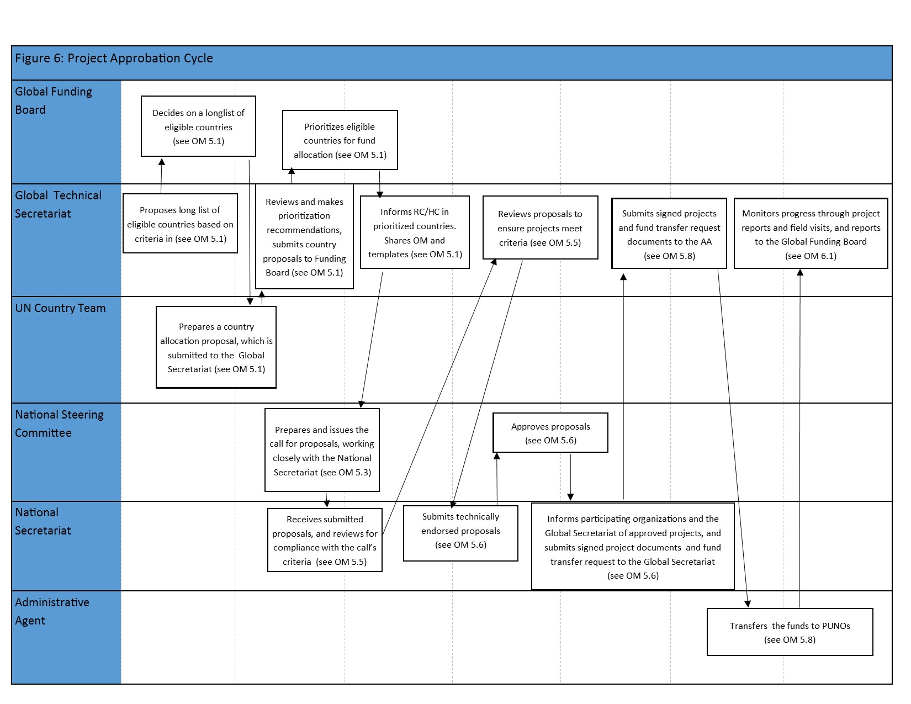

- The 2019 Call for Proposals in Palestine

A mapping of UN and major bilateral donors completed by the UNCT Hebron Task Force revealed only limited small scale investments in the Hebron area, focusing on awareness raising for communities on women's human rights and capacity building for local authorities. There are no significant or systematic investments in women's participation in political decision-making and conflict resolution or socio-economic recovery. In particular, rural women, women in Area C, Bedouin women, internally displaced women and female- headed households in the Hebron area fare the worst on socio-economic indicators in the West Bank. Priorities for women living in vulnerable and marginalized communities in Hebron particularly in H2 include economic empowerment, legal support, psychological and social support, GBV and related services, and carefully designed initiatives to support women’s participation in decision making and socio-economic recovery.

Women's civil society in Hebron and surrounding areas are particularly interested in addressing the vulnerabilities they face from the continuing conflict through the establishment of local women's protection committees and promoting women's participation in decision-making in the municipality and governorate and connecting also to national level policy makers and political actors and international advocacy fora. These interventions on participation in decision-making processes are complementary to increasing women's benefit from socio-economic recovery initiatives, in particular addressing gaps in access to transportation and childcare services as preconditions for improved mobility and economic empowerment.

Against this background, and in alignment with Palestine National Action Plan on UNSCR 1325, the Women’s Peace and Humanitarian Fund (WPHF) aims to increase the participation of women of Hebron in political decision-making, give voice to their protection concerns, and address and build their leadership and resilience in local communities.

With its 1st funding cycle in 2019, the Women’s Peace and Humanitarian Fund will fund qualifying projects in Palestine focusing on Hebron Governorate that contribute to one of the following Outcomes

1) Women's participation in decision-making processes and responses related to conflict prevention (WPHF Outcome 2).
2) Promotion of the socio-economic recovery and political participation of women and girls (WPHF Outcome 6).

- The WPHF will allocate up to US$2 million over three years to Palestine.

- Project proposals should be for no less than US$ 50,000 and no more than US$200,000.

- Submissions by a consortium of organizations/partners (two and more) which include grassroots/community-based organizations are highly encouraged.

- Applicants should outline specific measures to strengthen institutional capacity of their own as well as that of small CBOs/grassroots organizations, if applicable.

- Project submissions should ensure a strong focus on marginalized communities in Hebron including H2 and area C inside Hebron.

- The maximum project duration is 2 years.

- Application and Selection Process

Who is eligible to receive funding?

National and local registered civil society organizations are eligible to apply. Women’s grassroots/local/community-based organizations are particularly encouraged to apply. Joint CSOs projects are allowed and encouraged.

Do I need to be a legally registered entity/organization to apply?
Yes. The lead applicant Organizations must have legal status with the competent national authority as a non-profit, non-governmental and local organization. A proof of legal registration (or legal status) are a required attachment for any grant application. Applications without clear proof of legal status will be considered incomplete and will be withdrawn from the application process. Note that articles of incorporation are not proof of legal status.

Should I be located in Hebron?

Priority will be given to civil society organizations (particularly women’s organizations) who either:
- Have a main branch that is located in Hebron
- Have field presence in Hebron
- Are located elsewhere in the West Bank but have previous experience in implementing projects or programmes in Hebron.

May I submit more than one application?
No, organizations may not submit more than one application.

Can organizations apply jointly?
Yes, joint projects are encouraged particularly those that include grassroots organizations/community-based-organizations. For CSOs joint projects, only the lead organization is required to meet all the eligibility criteria. The roles, responsibilities and amount allocated for each partner out of the total budget must be clearly detailed within the application. Proposals must indicate which organization will take lead responsibility for project management and contractual obligations.

May I apply for funding for an ongoing initiative or project?
Yes, we will accept proposals for ongoing projects. However, the specific value added of the WPHF contribution should be clearly outlined.

Is there a recommended range for funding requests?

- Project proposals should be for no less than US$ 50,000 and no more than US$200,000.
- Submissions by a consortium of organizations/partners (two and more) which include grassroots/community-based organizations are highly encouraged.

What are the requirements for project design?

In Palestine, projects must contribute to one of the two following WPHF Outcome areas:

1) Women's participation in decision-making processes and responses related to conflict prevention.
2) Promotion of the socio-economic recovery and political participation of women and girls.

The Outcome of the Project must contribute to the overall WPHF’s results matrix (below).

Must applicants contribute to the project budget?
Civil society organizations are not required to contribute to the project budget.

Can my project be altered after approval?
Yes, a project may be altered, however organizations must submit a revised project document to the Technical Secretariat for re-approval.
7. Where, when and how to Apply?

The deadline for submission is 9 November 2019 (15:00 Jerusalem time). Applications received after that date will not be considered.

Application packages MUST be emailed to: palestine.registry@unwomen.org

Please submit applications in .doc, .docx, or .pdf format. No other formats will be accepted.

The WPHF will acknowledge receipt of application through a confirmation e-mail. If you do not receive the confirmation email within 48 hours, please contact the WPHF.

We can accept applications in English and Arabic. Only applications in these languages will be accepted.

You may not make changes to your application after it is submitted.

The designated WPHF Secretariat will be able to provide some support to grant applicants. Please note, support is limited and applicants are responsible for completing all components of the application themselves. Please allow 48 hours for responses to any questions.

7.1. Required Components of the Application Package

Please note, incomplete applications will not be considered.

Project Document (attached, no more than 10 pages)
Results Framework (see Project Document Annex: A)
Project Budget (see Project Document Annex: B)
Proof of legal registration or status

7.2. Evaluation Criteria
As you write your application, please keep in mind that proposals will be evaluated against the following criteria:

Programme management and monitoring:

A capacity building plan for CSO partners is in place to deliver programme results.
- Project workplan - in general, projects should not last for more than 24 months.
- The allocation of budget resources to monitor and evaluate project activities over time.

Budget:

The project falls within the limits set by the national steering committee.
- The budget is sufficient and reasonable for the activities proposed and takes the scale of problems into account.
- The budget includes indirect operational costs at the allowed level (no more than 7%).

Project design and objectives:
- Alignment with the WPHF’s theory of change, particularly with respect to a specific outcome and indicator in its results framework (see matrix below).
- Focus on marginalized and vulnerable communities in Hebron (H2 and Area C in Hebron).

Definition of objectives and results, taking account of previous evaluations if available in the same area.

Identification of a credible implementation strategy and sequential operation of activities
- Partnership with, and capacity development of local women’s organizations. Joint projects are strongly encouraged.
- Identification of risks and appropriate mitigation measures.
- Complementarity with other Funds and Programmes.
- Relevance of the project for the targeted groups

Viability and national ownership:

Promotion of national and local ownership in developing and establishing activities, and specific objectives to build the capacities of national and local players.

Implementation of partnership with national CSOs.
- Viability of the programme beyond the financing period and (where applicable), how to reproduce it and improve it over time.

- Useful Resources

- The Women’s Peace and Humanitarian Fund’s Operations Manual
- The WPHF’s 2-pager
- The WPHF’s website www.wphfund.org
- The WPHF’s page on the Multi-Partner Trust Fund Office’s Gateway: http://mptf.undp.org/factsheet/fund/GAI00
- The WPHF’s Twitter account: @wphfund
- M&E and Results Based Management Terms. The OECD/DAC Glossary of Key Terms in Evaluation available in English, French and Spanish. http://www.oecd.org/dataoecd/29/21/2754804.pdf
- M&E Standards and Guidelines. The United Nations Evaluation Group (UNEG) Standards for Evaluations, available in English, French, Spanish, Arabic and Russian http://www.uneval.org/papersandpubs/documentdetail.jsp?doc_id=22

Women’s Peace and Humanitarian Fund
(WPHF)

Project Document
(Length – 7-10 pages)

- Project document Cover Page
Project Title: |  | PUNO: UN Women
Project Contact:  Name:  Entity:  Title:  Email: |  | Implementing Partner(s):
 |  | Country:
Total Project Cost:
WPHF’s contribution:
Other contributions:
Proposed Project Start Date:
Proposed Project End Date:
Total duration (in months):
WPHF’s Outcome the project is contributing to:

WPHF’s Outcome indicator the project will be reporting on:

PUNO(s) and Implementing Partners
Name of PUNO  Name of PUNO Representative  Title  Signature  Date & Seal | Name of CSO  Name of CSO Representative  Title  Signature  Date & Seal

- Executive Summary

The executive summary provides an overview of the project, how it will contribute to accelerating peace or humanitarian relief, the intended results and why they are important, and a description of the strategy for their achievement. Basic data includes: project duration, total budget, funding sources, partners, target beneficiaries, governance structure;

- Context and Situation Analysis

The context should provide an analysis of the broad political context – nature of conflict / emergency/ humanitarian situation. It should also contain an analysis of the situation of women/gender equality the Project aims at addressing

- Rationale for WPHF’s support

This section will provide an overview of other women, peace, security and humanitarian initiatives and projects and gaps at the national level and/or in the geographic area of the project. It will explain the added value the project and how it would complement other initiatives.
It will also contain the problem statement and how the Project intends so solve it (underlining added value of investing in women in order to accelerate peace). This section can build on documented evidence, lessons, and good practices of past initiatives in the country, region and locality.
It will explain how the requesting organization(s) has the knowledge/expertise/partnerships to successfully achieve results.

- Results and Resources Framework

This section describes the results to be achieved by the Project and the means of implementation (narrative).
The results will also be formulated in a results framework (using the same format in Annex A).
The Project’s Outcome is repeated from the WPHF’s Outcome(s) selected in the Country’s allocation.
The Project’s outputs can be repeated from the WPHF’s results framework (indicative outputs indicators are also provided).
New indicators must be SMART and contribute to higher level of WPHF’s Theory of Change. Key activities that are necessary to produce each output are also defined. Activities do not have indicators. In the “Means of Verification/Sources of Information” column, identify the methods and sources of information that will be used to measure performance against the indicators.
A Resource framework using UNDG’s categories will also be included (See Annex B).

- Partnerships

This section will provide a partners’ assessment detailing each partner’s role, added value and capacities (UN entities, Government and Civil Society Organizations).
A particular attention will be given to explaining how partnerships and coalition building will help support local, grassroots and/or community women’s or women’s rights CSOs.

- Monitoring, reporting and management Arrangements

This section will describe the management arrangements, as well as monitoring, evaluation (if any), reporting and research activities (including the research projects) that will be developed through this Project, if any). This section will also include a risk analysis and proposed mitigation measures.

VIII. Sustainability

This section will describe how the results’ sustainability will be ensured
Annex A: Results framework
Results | Indicators | Means of Verification/Sources of Information | Activities | Budget
Outcome | Outcome indicator  Baseline:  Target:
Output 1.1 | Output indicator(s)  Baseline:  Target:
Output 1.2.
Output 1.3.

Annex B - Budget per category

UNDG Categories | Amount (US$)
1. Staff and other personnel costs
2. Supplies, Commodities and Materials
3. Equipment, Vehicles and Furniture, including Depreciation
4. Contractual Services
5. Travel
6. Transfers and Grants to Counterparts
7. General Operating Expenses and Other Direct Costs
Sub-total
8. Indirect Support Costs *
TOTAL
*The rate shall not exceed 7% of the total of categories 1-7. Note that PUNO/Implementing Partner -incurred direct project implementation costs should be charged to the relevant budget line, according to the PUNO/Implementing Partner s regulations, rules and procedures

The WPHF’s Results Matrix

Impact: More peaceful and gender equal societies

Outcome 2: Women’s meaningful participation in conflict prevention |  |  |  |  | Financial Investment: Y1- $XX; Y2 - XX; Y3- XX
Outcome indicators | Baseline | Target Year 1 | Target Year 2 | Target Year 3 | Means of Verification
Number of cases of conflicts (e.g. familial, domestic, land, social, political, etc.) referred to local women mediators. |  |  |  |  | WPHF Reporting. Country reporting by UNDP and UN Women.
Outcome 6: Promotion of the socio-economic recovery and political participation of women and girls |  |  |  |  | Financial Investment: Y1- $XX; Y2 - XX; Y3- XX
Outcome indicators | Baseline | Target Year 1 | Target Year 2 | Target Year 3 | Means of Verification
Labor force participation rate for persons aged 15+, by sex |  |  |  |  | ILO
Proportion of informal employment in non-agriculture employment, by sex |  |  |  |  | ILO
Proportion of seats held by women in national parliaments |  |  |  |  | SDG indicator

Global Study on the implementation of the UN Security Council resolution 1325, 2015
OECD-DAC Gender Equality Network. “Financing Security Council resolution 1325 (2000).” March 2015
Visioning the Future: Reporting the findings of the Future of Humanitarian Financing initiative and dialogue processes (2015).
Previously the Global Acceleration Instrument on Women, Peace and Security and Humanitarian Action
UN Women “caught up between a rock & a hard place: occupation, patriarchy and gender relations a case study of Palestinian women in area C & H2”, March 2018
In the case of a CSO submitting a proposal, the PUNO will be the Management Entity (UN Women where UN Women has a country presence) and the Implementing Partner will be the submitting CSO
Name of the applicant organizations
A project can only contribute to one Outcome. Please choose Outcome 2 (conflict prevention) OR Outcome 6 (recovery)
The Outcome indicator is repeated from the WPHF’s results framework. Please choose from Outcome 2 OR Outcome 6 indicators
Please add signature block for each PUNO receiving funds under this project.
In the case of a CSO submitting a proposal, the PUNO is the Management Entity
In the case of a CSO submitting a proposal directly to the Steering Committee
A project can only contribute to one Outcome.
The Outcome will be selected from WPHF’s Results Matrix below
The Outcome indicator will be selected from WPHF’s Results Matrix below
Outputs are concrete deliverables. For example, an output could be the number of women trained to monitor early warning signals.

